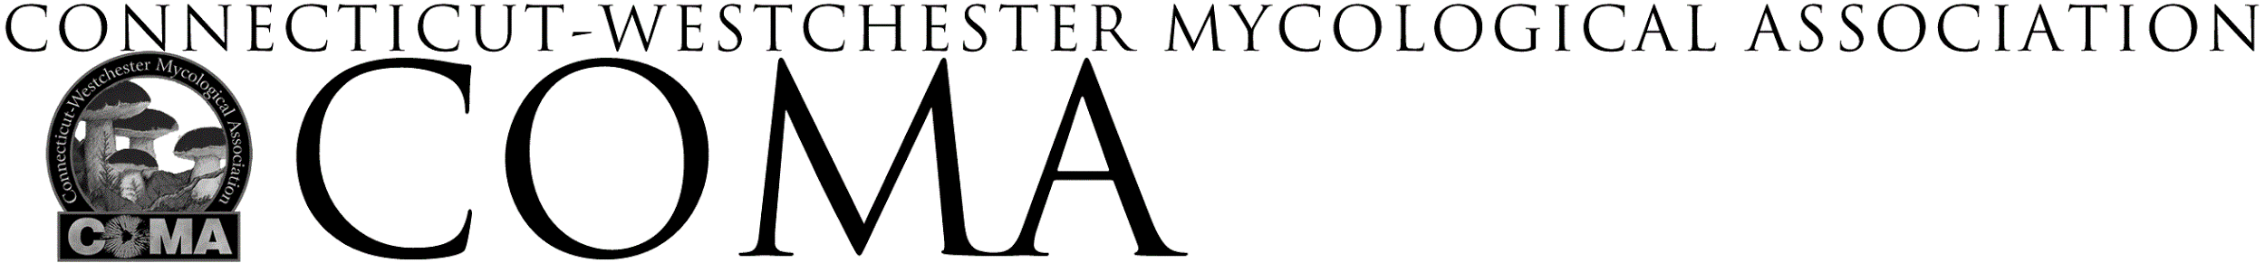SYLVIA STEIN SCHOLARSHIP
GUIDELINES

The Connecticut Westchester Mycological Association, established in 1975, has created a scholarship program in honor of Sylvia Stein, a founding member of COMA. Sylvia was an amateur naturalist, mycologist, and educator. She was an inspiring teacher, frequent lecturer on mushroom identification and recipient of the NAMA Harry and Elsie Knighton Service Award for her lifelong contributions to amateur mycology.

As an organization of volunteers and committed amateur mycologists, our hope is that this scholarship program will stimulate further interest and study in the amazing world of fungi. The Sylvia Stein Scholarship provides financial support to an outstanding applicant wishing to advance and share their knowledge of mycology and mushroom identification by attending a mycology-related educational event or by creating a mycology-related project.

Scholarship Guidelines
- The total COMA scholarship fund is $1,500
- Individuals may request funding by submitting a completed application
- Individual scholarship awards will not exceed $300
- Applications will be received on a rolling basis
- Only mycology-related events or projects are eligible for consideration
- Applicant must be a current member of COMA for at least one year
- Preference will be given to events held in the Northeast
- Events must be no more than 12 months after the application submission date
- Recipients are expected to lead one COMA walk
- Recipients are expected to submit an article to COMA’s quarterly newsletter Spores Illustrated to share their experience
- COMA does not assume liability for activities associated with this scholarship

Suggested events include attending COMA’s Mushroom University, Eagle Hill Institute, New York Botanical Garden, forays, mushroom-related workshops, etc. Mycology projects involving cultivation, photography, microscopy, culinary arts, crafts, etc. are also eligible. Priority will be given to projects designed to increase the applicant’s ability to aid club members with mushroom identification.

An applicant’s personal financial situation is neither a requirement for eligibility nor a factor in scholarship determination.

Applications and guidelines may be downloaded at: https://www.comafungi.org/learn/scholarships/

Applications are to be submitted to: kbrandt1@optonline.net

